DAY - 13

1.Prims algorithm

import heapq

from collections import defaultdict

def prim(graph):

if not graph:

return [], 0

start_node = next(iter(graph))

mst = []

total_weight = 0

visited = set([start_node])

min_heap = [(weight, start_node, neighbor) for neighbor, weight in graph[start_node].items()]

heapq.heapify(min_heap)

while min_heap:

weight, u, v = heapq.heappop(min_heap)

if v not in visited:

visited.add(v)

mst.append((u, v, weight))

total_weight += weight

for neighbor, weight in graph[v].items():

if neighbor not in visited:

heapq.heappush(min_heap, (weight, v, neighbor))

return mst, total_weight

if __name__ == "__main__":

graph = {'A': {'B': 2, 'C': 3},

'B': {'A': 2, 'C': 1, 'D': 1},

'C': {'A': 3, 'B': 1, 'D': 2},

'D': {'B': 1, 'C': 2}}

mst, total_weight = prim(graph)

print("Edges in the Minimum Spanning Tree:")

for edge in mst:

print(edge)

print("Total weight of the Minimum Spanning Tree:", total_weight)

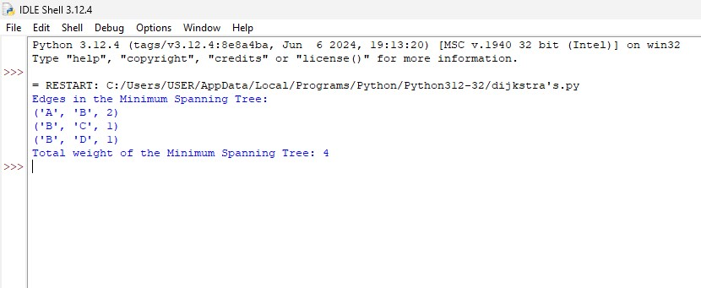

2. Backtracking

def is_safe(board, row, col, N):

for i in range(row):

if board[i][col] == 1:

return False

for i, j in zip(range(row, -1, -1), range(col, -1, -1)):

if board[i][j] == 1:

return False

for i, j in zip(range(row, -1, -1), range(col, N)):

if board[i][j] == 1:

return False

return True

def solve_n_queens_util(board, row, N, solution):

if row == N:

solution.append(["".join("Q" if x == 1 else "." for x in row) for row in board])

return True

for col in range(N):

if is_safe(board, row, col, N):

board[row][col] = 1

solve_n_queens_util(board, row + 1, N, solution)

board[row][col] = 0

return False

def solve_n_queens(N):

board = [[0] * N for _ in range(N)]

solution = []

solve_n_queens_util(board, 0, N, solution)

return solution

if __name__ == "__main__":

N = 4

solutions = solve_n_queens(N)

for idx, solution in enumerate(solutions, start=1):

print(f"Solution {idx}:")

for row in solution:

print(row)

print()

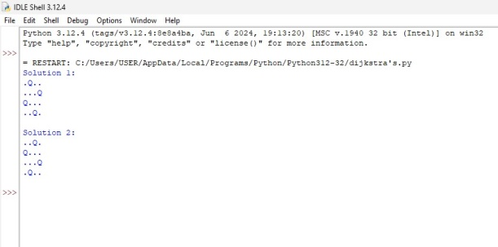

3. N queens problem

global N

N = 4

def printSolution(board):

for i in range(N):

for j in range(N):

print (board[i][j],end=' ')

print()

def isSafe(board, row, col):

for i in range(col):

if board[row][i] == 1:

return False

for i, j in zip(range(row, -1, -1), range(col, -1, -1)):

if board[i][j] == 1:

return False

for i, j in zip(range(row, N, 1), range(col, -1, -1)):

if board[i][j] == 1:

return False

return True

def solveNQUtil(board, col):

if col >= N:

return True

for i in range(N):

if isSafe(board, i, col):

board[i][col] = 1

if solveNQUtil(board, col + 1) == True:

return True

board[i][col] = 0

return False

def solveNQ():

board = [ [0, 0, 0, 0],

[0, 0, 0, 0],

[0, 0, 0, 0],

[0, 0, 0, 0]]

if solveNQUtil(board, 0) == False:

print ("Solution does not exist")

return False

printSolution(board)

return True

solveNQ()

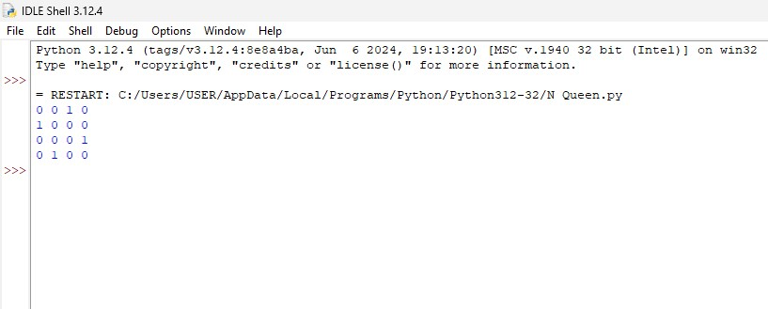

4. Sudoku solver

def is_valid(board, row, col, num):

if num in board[row]:

return False

for i in range(9):

if board[i][col] == num:

return False

start_row, start_col = 3 * (row // 3), 3 * (col // 3)

for i in range(start_row, start_row + 3):

for j in range(start_col, start_col + 3):

if board[i][j] == num:

return False

return True

def solve_sudoku(board):

empty_cell = find_empty_cell(board)

if not empty_cell:

return True

row, col = empty_cell

for num in range(1, 10):

if is_valid(board, row, col, num):

board[row][col] = num

if solve_sudoku(board):

return True

board[row][col] = 0

return False

def find_empty_cell(board):

for i in range(9):

for j in range(9):

if board[i][j] == 0:

return (i, j)

return None

def print_board(board):

for row in board:

print(" ".join(map(str, row)))

if __name__ == "__main__":

board = [[5, 3, 0, 0, 7, 0, 0, 0, 0],

[6, 0, 0, 1, 9, 5, 0, 0, 0],

[0, 9, 8, 0, 0, 0, 0, 6, 0],

[8, 0, 0, 0, 6, 0, 0, 0, 3],

[4, 0, 0, 8, 0, 3, 0, 0, 1],

[7, 0, 0, 0, 2, 0, 0, 0, 6],

[0, 6, 0, 0, 0, 0, 2, 8, 0],

[0, 0, 0, 4, 1, 9, 0, 0, 5],

[0, 0, 0, 0, 8, 0, 0, 7, 9]]

print("Original Sudoku board:")

print_board(board)

print("\nSolving...\n")

if solve_sudoku(board):

print("Solved Sudoku board:")

print_board(board)

else:

print("No solution exists for the given Sudoku board.")

